### Sec. 5.2. Signs

#### Intent and Purpose

1. It is recognized that signs perform important functions in the City, which are essential for the public safety and general welfare, such as

communicating messages, providing information about goods and services available, and providing orientation. It is further recognized that because of their potential detrimental impact on the visual and perceptual environment, signs must be regulated in order to:

* 1. Prevent hazards to vehicular and pedestrian trafﬁc;
  2. Prevent conditions which have a blighting inﬂuence and contribute to declining property values;
  3. Provide for easy recognition and legibility of all permitted signs and other uses in the immediate vicinity; and
  4. Preserve the amenities and visual quality of the City and curb the deterioration of the village commercial areas.

1. It is the intent of these provisions to protect property values, create a more attractive business climate, enhance and protect the physical appearance of the City, provide a more enjoyable and pleasing environment and to encourage the most appropriate use of land.

(Ord. No. 158, 10/18/76)

#### Applicability

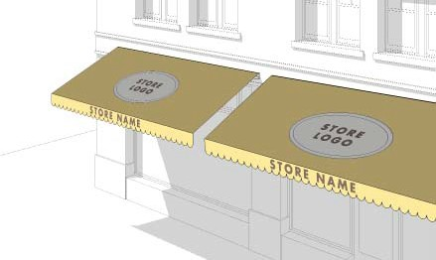All signs shall comply with the regulations for the erection and construction of signs contained in the 780 CMR and applicable City ordinances. No sign shall be erected, displayed, or maintained within the City, except those speciﬁcally provided for in this Sec. 5.2 or in other chapters of the Revised Ordinances.

(Ord. No. 196, 2/22/77)

#### Definitions

Sign. A permanent or temporary structure, device, letter, word, 2D or 3D model, insignia, banner, streamer, display, emblem, or representation which is an advertisement, announcement or direction, or which is designed to attract attention.

Sign, Accessory. A sign that, with respect to the premises on which it is erected, advertises or indicates one or more of the following: the address and/or occupant of the premises, the business transacted on the premises, the year the business was established, a slogan, directional or parking instructions, or the sale or letting of the premises or any part thereof.

Sign, Area. The entire area within a single continuous perimeter, and a single plane, which encloses

the extreme limits of the advertising message or announcement or wording together with any frame, background, trim, or other integral part of the display excluding the necessary supports or uprights on which the sign is placed. Sign area of a free-standing sign or a perpendicular wall sign is the entire area of one side

of such sign such that two faces which are back to back are counted only once.

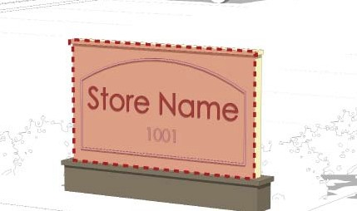

Sign, Awning. A sign on or attached to a temporary retractable shelter which is supported entirely from the exterior wall of a building.

Sign, Directional. Signs indicating “Entrance,” “Exit,” “Parking,” or the like, erected on a premises for the direction of persons or vehicles.

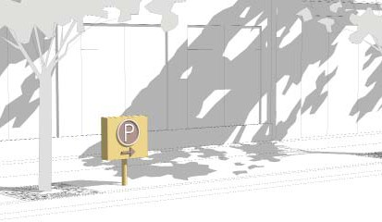

Sign, Free-Standing. A sign erected on or afﬁxed to the land by post, pole, pylon or any framing or supporting device or stand which is not afﬁxed to a building, and may inlcude kiosks or public information bulletin boards.

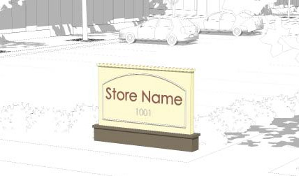

Sign, Frontage. The length in feet of the building wall parallel or substantially parallel to a street that is occupied by an individual business establishment.

Sign, Noncommercial. A sign which contains only noncommercial messages.

Sign, Marquee. A sign on or attached to a permanent overhanging shelter which projects from the face of a building, is entirely supported by said building, and may have a changeable letter panel.

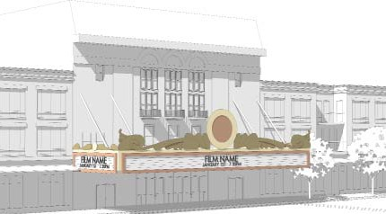

Sign, Non-Accessory. A billboard, sign or other commercial advertising device which does not come within the foregoing deﬁnitions of an accessory sign or of a non- accessory directory sign, or of a noncommercial sign.

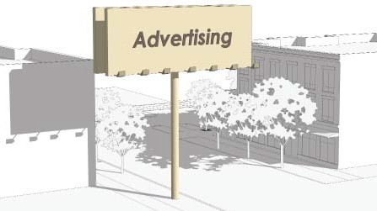

Sign, Non-Accessory Directory. A sign that, with respect to the premises on which it is erected and/

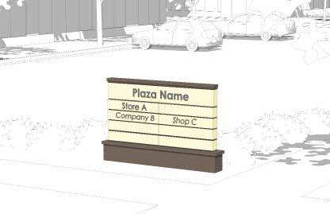or an adjacent premises for which the sign is a single common identiﬁer, or with respect to a single integrated development consisting of two or more lots, advertises or indicates one or more of the following: the address and/ or occupant of the premises, the business transacted on the premises, the year the business was established, a slogan, directional or parking instructions, or the sale or letting of the premises or any part thereof.

Sign, Principal. The principal sign on a lot. Where permission is granted for a free-standing sign, the free- standing sign shall be considered the principal sign.

Sign, Secondary. A wall sign located on a wall other than that occupied by the principal sign.

Sign, Wall. A sign afﬁxed either parallel or perpendicular to the wall of a building and not extending above the roof plate or parapet line.

* + - 1. Wall signs shall be afﬁxed either parallel or perpendicular to a wall of a building. Where a building or structure to which a parallel wall sign is to be afﬁxed has an identiﬁable sign band,

as determined by the Director of Planning and Development in consultation with the Urban Design Commission, or is part of a block of commercial establishments which, except for the petitioned property, is the subject of uniform signage, the parallel wall sign shall be located within the identiﬁable sign band or shall be consistent with any uniform signage.

* + - 1. A parallel wall sign shall project no more than 12 inches from the building surface and shall not extend above the roof line or beyond the sides of the building.
      2. A perpendicular wall sign shall be attached at a right angle to the wall of a building; it shall have no more than 2 faces; and it shall not project in any linear dimension more than 6 feet, subject to the provisions of Revised Ordinances Chapter 26, Sections 26-1 to 26-6. When a projecting sign is closer than 12 feet

to the corner of a building, its projection shall be no more than a distance equal to 1/2 the horizontal distance from the sign to that building corner.

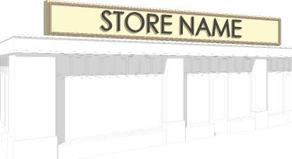

Sign, Window. A sign afﬁxed to the interior or exterior surface of a window or displayed behind a window so as to attract attention from the outside. A sign shall be

deemed a window sign if it is within 6 inches of the inside surface of a window through which it is intended to be viewed and is not merchandise on display.

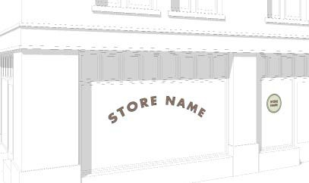

(Ord. No. 158, 10/18/76; Ord. No. V-7, 03/20/95)

#### Permit Procedure

1. No sign shall be erected on the exterior of any building or on any land, and no such sign shall be enlarged or altered, with the exception of copy changes on changeable letter panels, clocks, or thermometers, until an application on appropriate

forms supplied by the Commissioner of Inspectional Services with such information including plans, drawings, and photographs as the Commissioner

of Inspectional Services may require, shall have been ﬁled with the Commissioner of Inspectional Services, and a permit for such erection, alteration or enlargement has been issued by the Commissioner of Inspectional Services.

1. All non-accessory directory signs shall obtain an outdoor advertising permit from the Commonwealth of Massachusetts’ Office of Outdoor Advertising.
2. Upon receipt of an application for a sign permit, the Commissioner of Inspectional Services shall notify the Urban Design Commission and the Director of Planning and Development regarding said application within 2 weeks of the date of ﬁling, if they deem it necessary. The Director of Planning and Development shall submit an advisory report,

including any recommendation of the Urban Design Commission, to the Commissioner of Inspectional Services within 3 weeks of the application ﬁling date.

1. The fees for sign permits shall be established from time to time by the City Council.
2. Within 2 months after the erection, alteration or enlargement of any sign, the owner or operator

of said sign shall ﬁle two 8 inch by 10 inch photographs, taken after intallation.

(Ord. No. 158, 10/18/76)

#### Prohibited Signs

The following signs shall not be permitted, constructed, erected, or maintained:

1. Non-accessory signs;
2. Signs constructed, erected, or maintained on the roof of a building or which extend above the roof plate line;
3. Portable signs not permanently afﬁxed, anchored, or secured to the ground or a structure on the lot it occupies, including trailer signs and signs afﬁxed to or painted on a vehicle permanently parked on

the premises so as to serve as a sign, but excluding signs afﬁxed to or painted on a vehicle temporarily parked on the premises;

1. Window signs which cover more than 25 percent of the area of the window;
2. Any sign which advertises or calls attention to any products, businesses, or activities which are no longer sold or carried on at any particular premises; or
3. String lights used in connection with commercial premises with the exception of temporary lighting for holiday decoration.

(Ord. No. 158, 10/18/76)

#### Signs Allowed By Right

1. Permanent Signs. The following signs shall be allowed by right without the necessity of sign review, but may require a building permit:
   1. Signs erected by or on the order of a governmental agency when limited to governmental purposes, and excluding any advertising, except in the Open Space/

Recreation and Public Use districts (see Sec. 6.2.9);

* 1. Names of buildings, date of erection, monumental citations and commemorative

tablets, when made a permanent and integral part of a building, not to exceed 10 square feet;

* 1. Banners or ﬂags emblematic of or issued by national, state, or local governments;
  2. Signs indicating the name and address of the occupant of a dwelling, not to exceed 1 square foot. Where a permitted accessory home business exists, such sign shall not exceed 2 square feet;
  3. Awning signs in business, mixed use, limited manufacturing and manufacturing districts;
  4. Window signs, in nonresidential buildings, not to exceed 25 percent of the area of the window;
  5. Customary signs on gasoline pumps indicating in usual size and form the name, type and price of gasoline;
  6. Clocks and thermometers displaying no information other than the time and temperature;
  7. Holiday decorations and lights when in season; and
  8. Signs not to exceed 2 square feet which indicate warnings, hazards, or public conveniences such as “trespass,” “beware of dog,” or rest room signs.

1. Temporary Signs. Temporary signs shall not be illuminated and shall comply with the provisions of this Sec. 5.2, but may require a building permit:
   1. Short-Term Event Sign. The Commissioner of Inspectional Services may permit an

establishment to display on its premises 1 non- illuminated sign announcing a special event of limited duration to take place on the premises.

Such sign may be displayed for a period not to exceed 72 hours, including time required for installation and removal. The Commissioner of Inspectional Services shall issue such a permit to the same establishment no more than twice

per calendar year. Applications for such permits shall be submitted in accordance with Sec.

5.2.4, but shall be submitted no later than 1 week prior to the proposed date of installation. Applications for such permits shall not be subject to notice to and review by the Urban

Design Commission and the Director of Planning and Development.

1. Temporary Identification Sign Procedure. One temporary identiﬁcation sign to identify a property or use during the period from the submission of a sign application to the

Commissioner of Inspectional Services or during the special permit procedure to 30 days after the decision, may be erected, provided that

in the event of an unfavorable decision such temporary sign shall be removed immediately, and provided that the temporary sign conforms with all applicable dimensional regulations of this Sec. 5.2, that it is, in fact, a temporary sign not involving any substantial expense, and that it is displayed in a manner which will not deface the building facade or otherwise impinge upon the review of the proposed sign.

1. Construction Signs. One or more signs during the construction or alteration of a building identifying the building, owner, contractor, architects and engineers and whether any business is or is not to be conducted there may be erected. Such signs shall not exceed in the aggregate 32 square feet and shall be

removed within 48 hours after completion of the construction or alteration.

1. Real Estate Signs. One unlighted sign, not exceeding 12 square feet in residential districts and 32 square feet in commercial districts, advertising the sale, rental or lease of the premises or part of the premises or the willingness to build on the premises on which the sign is displayed may be erected. Such

signs shall be removed within 48 hours after the sale, rental or lease of the premises.

1. Event Signs. Signs not exceeding 30 square feet, announcing a fundraising drive or event of a civic, philanthropic, educational or religious organization, displayed on the lot of the event or the property of the sponsoring agency and limited to 1 per lot, except that if a lot has frontage on more than one street, there may be a free-standing sign for each street frontage.

Such signs shall not be erected before 14 days preceding the event and shall be removed within 48 hours after the event.

6. Noncommercial Signs. Noncommercial signs shall be allowed in all zoning districts, except as otherwise provided in this Chapter, and shall conform to the following:

A. The face of the sign shall be no higher than and no wider than 3 feet;

B. Signs may be located anywhere on a lot, but shall not create a traffic safety hazard by blocking visibility of traffic on a public street from a driveway. Signs shall not overhang a public sidewalk; however, where there is no sidewalk, no part of the sign shall be closer than 8 feet to the edge of the paved portion of the public way;

C. Signs shall not include any names or logos advertising goods, services, or businesses or otherwise constituting commercial speech;

D. Signs shall not be artificially illuminated except as permitted by Sec. 5.2.10.

(Ord. No. 158, 10/18/76; Ord. No. T-64, 12/18/89; Ord. No. V-7, 03/20/95; Ord. No. Z-27, 05/19/08; Ord. No. A-29, 10/07/13; Ord. No. A-99, 01/17/17)

#### Signs in Residence Districts

No permanent sign shall be erected or maintained in a residence district, except as provided in Sec. 5.2.6 and this Sec. 5.2.7:

Notes

Area per Sign

(max)

Type

Number

Use

Residential: single- or two-family 1 per unit Wall sign 1 sf Name of occupant,

address of premises

Residential: single- or two-family with permitted accessory use or occupation

1 per unit Wall sign 2 sf

Name of occupant(s), address of premises

Residential: building with more than 2 families or group of buildings forming a single housing development

Residential: Each building in

1 total

1. per building

Principal wall sign OR

Free-standing sign

Secondary wall

15 sf OR

10 sf

a group of buildings forming a single housing development

Churches, schools, other

in group

sign 2 sf

Free-standing sign

1 Free-standing sign

institution or group of buildings forming a complex or campus

Churches, schools, or other institutions: Each building in a group of buildings forming a single complex or campus

1. per street frontage

1 per building in group

AND

principal wall sign

Free-standing sign AND

principal wall sign

1 @ 20 sf

1 @ 10 Ssf

10 sf

per frontage; for notices and announcements of services and events

Nonresidential use, permitted or nonconforming

1 total Principal wall sign 20 sf

1 total Free-standing sign 15 sf

The City Council may grant a special permit for a free-standing sign

For the direction of

Any use -- Directional sign 3 sf

Persons or vehicles, indicating “entrance,” “exit,” “parking,” or the like

-- Not Applicable

#### Signs in Commercial Districts

No permanent sign shall be erected or maintained in a business, limited manufacturing, manufacturing, and mixed use district, except as provided in Sec. 5.2.6 and this Sec. 5.2.8:

Notes

Area per Sign (max)

Number per business

establishment

Type

Principal sign 1 total

Principal sign:

3 sf per linear foot of building wall frontage OR

100 sf, whichever is less

3 sf per linear foot of

In particular instances, due to the nature of the use of the premises, the architecture of the building, or its location with reference to the street, the total allowable sign area may be divided between two wall signs which together constitute the principal wall sign.

Business on a corner lot

Secondary sign

2 total

1 per entrance or frontage on a street or parking area; 2 max

building wall OR

100 sf, whichever is less

1 sf per linear foot of building wall

OR

50 sf, whichever is less

Frontage on the second street must be at least 75 percent of frontage on ﬁrst street

May not be erected on the same wall as a principal sign.

Directory sign 1 per building Directory sign:

entrance

building with 2nd 1 per entrance entrance

1 sf per occupant or tenant

1 sf per occupant or tenant

Indicating the occupants or tenants of the building to which the sign is afﬁxed

The second entrance must have frontage on a street or parking lot. Such signs shall not be deemed nonaccessory directory signs.

Marquee sign 1 per theater

Awning sign --

Up to 20% of awning area

Up to 25% of window

Window sign --

Gas station sign 1 consolidated

display

area through which they are visible

20 sf (aggregate) Product identiﬁcation signs (tires, oil...)

For the direction of persons or vehicles, in- dicating “entrance,” “exit,” “parking,” or the like

Directional sign 3 sf

-- Not Applicable

(Ord. No. A-99, 01/17/17; Ord. No. B-2, 02-20-18)

#### Signs in Open Space/Recreation and Public Use Districts

In Open Space/Recreation and Public Use districts, no sign shall be erected, displayed or maintained except as provided below:

1. Regulatory signs as may be erected by the City, county, state, or their agencies.
2. Signs for the identiﬁcation of public buildings or public premises, or allowed uses in open space/ recreation and public use districts, or valid nonconforming uses existing in open space/ recreation and public use districts. These identiﬁcation signs shall not exceed 20 square feet in area.
3. The City Council may permit free-standing signs, public information bulletin boards and exceptions to the maximum area requirement of 20 square feet for signs set out above, as provided for in Sec. 5.2.13. In no event shall any free-standing sign exceed 35 square feet in area in an Open Space/Recreation or Public Use district.

(Ord. No. 51, 02/03/75; Ord. No. 158, 10/18/76; Ord. No. V-90, 09/03/96)

#### Illuminated Signs

1. No sign shall contain any moving parts or ﬂashing or blinking lights so as to create an animated effect, except such portions of a sign which consist solely of indicators of time and temperature.
2. No red or green lights or any lighting effect utilizing such colors shall be used on any sign if, in the opinion of the Chief of Police, such light or lighting effect would create a hazard to the operation of motor vehicles.
3. Any lighting of a sign shall be continuous and shall be either interior, non-exposed or exterior illumination. All illumination shall be of reasonable intensity and shielded in such a manner that all direct light falls on the sign or the wall to which it is

afﬁxed and does not shine onto any street or nearby property.

1. No sign shall be lighted between the hours of 11:00

p.m. and 7:00 a.m., except those signs identifying police or ﬁre stations, a residential building, or in the case of a commercial establishment, signs which may be lighted during a period extending from 30 minutes before opening for business and to 30 minutes after closing.

1. The City Council may grant a special permit for the illumination of other signs if the City Council ﬁnds that such illumination is in the public interest.

(Ord. No. 89, 10/06/75; Ord. No. 158, 10/18/76)

#### Construction and Maintenance

1. The construction, alteration, repair and maintenance of all signs, together with their appurtenant and auxiliary devices in respect to structural and ﬁre safety, shall be governed by the provisions of the 780 CMR. Where provisions of this Sec. 5.2 are more restrictive with respect to location, use, size or height of signs and other applicable regulations, this Sec. 5.2.11 shall take precedence.
2. No sign shall be erected so as to obstruct any door, window or ﬁre escape on a building.
3. Any sign which advertises or calls attention to any products, businesses or activities which are no longer sold or carried on at any particular premises shall be removed by the occupant or owner of

the premises within 30 days. If any such sign is not removed within 30 days, the Commissioner of Inspectional Services shall give written notiﬁcation,

in hand or by certiﬁed mail, return receipt requested, to the owner or occupant of the premises that the Commissioner of Inspectional Services will have such sign removed and assess any costs of the removal to the owner or occupant. If within 30 days from the date of receipt of the notiﬁcation the sign has not been removed by the owner or occupant, then the Commissioner of Inspectional Services shall remove said sign and assess any costs of the removal to the owner or occupant.

(Ord. No. 158, 10/18/76; Ord. No. R-273, 11/15/82)

#### Nonconforming Signs

1. Any nonconforming sign legally erected prior to the adoption of this Sec. 5.2, or any amendment of this Sec. 5.2, may be continued to be maintained but shall not be enlarged, reworded, redesigned or altered in any way unless it conforms with the provisions contained of this Sec. 5.2.
2. The exemption granted in paragraph A. above shall not apply to any non-accessory sign or to any sign which has been illegally erected, has been abandoned, or has not been repaired or properly maintained.
3. Any sign which has been destroyed or damaged to the extent that the cost of repair or restoration will exceed one-third of the replacement value as of the date of destruction shall not be repaired, rebuilt, restored or changed unless it conforms with this Sec. 5.2.

(Ord. No. 158, 10/18/76)

#### Exceptions

A. In particular instances, the City Council may grant a special permit to allow free-standing signs and exceptions to the limitations imposed by this Sec.

5.2 on the number, size, location and height of signs where it is determined that the nature of the use of the premises, the architecture of the building or its location with reference to the street is such that free- standing signs or exceptions should be permitted in the public interest.

1. In granting such a permit, the City Council shall specify the size, type and location and shall impose such other terms and restrictions as it may deem to be in the public interest and in accordance with the 780 CMR. All free-standing signs shall not exceed 35 square feet in area, or 10 feet in any linear dimension, or 16 feet in height from the ground, except as further described in Sec. 5.2.7.
2. Where a single lot is occupied by more than 1 establishment, whether in the same structure or not, there shall not be more than one free-standing sign for each street frontage. In granting such a permit, the City Council shall specify the size, type and location of any such sign and shall impose such other forms and restrictions as it may deem to be in

the public interest, and in accordance with the 780 CMR.

(Ord. No. 158, 10/18/76)

#### Guidelines

The Director of Planning and Development may from time to time prepare and issue guidelines to clarify the provisions of this Sec. 5.2.

(Ord. No. 158, 10/18/76)

10-36’ 10’ 1’ for every foot of equipment height, including antenna

* 1. If there is a parapet on any building or structure which does not exceed 36 feet in height and if the roof- mounted wireless communication equipment will be transmitting or receiving in the direction of that parapet, the required setback from the edge