June 10, 2022

Dear Mayor Fuller,
We have been informed that the Massachusetts Department of Public Health is granting an additional $58,239.50 to the City of Newton to be used for COVID-19 related expenses.
Please amend my prior request of $41,760.50 to reflect this increased amount.
This funding is in addition to the previous allocation of $114, 682 recently approved by council.
These funds will be used for COVID-19 related expenses such as testing, extra school nurse staffing and contact tracing and must be expended by June 30, 2022.
Sincerely,
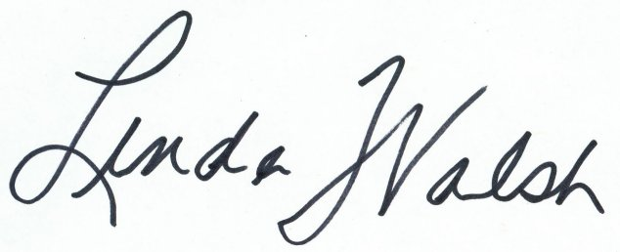
Linda Walsh
Commissioner
Newton Health and Human Services

