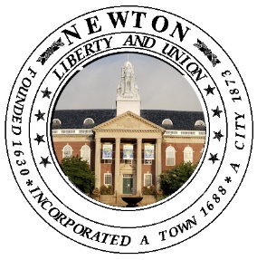

**CITY OF NEWTON, MASSACHUSETTS**

PUBLIC BUILDINGS DEPARTMENT

52 ELLIOT STREET, NEWTON HIGHLANDS, MA 02461

**Telephone (617) 796-1600  
Facsimile (617) 796-1601**

**TDD/tty # (617) 796-1608**

Ruthanne Fuller, Mayor

Josh Morse, Building Commissioner

Date: Monday April 10th

Subject: Franklin Elementary School Project

The City of Newton and Newton Public Schools are working on a major capital project at the Franklin Elementary School. The design work started early in 2022, before pausing in the fall of 2022 while we awaited the results of the override. Now that the voters have approved the project funds, the Franklin School Project is moving forward.

You’re receiving this letter due to your proximity to the school, and we would welcome your voice and input into the design process. If you are interested in staying up to date on the project, please email us at [franklin@newtonma.gov](mailto:franklin@newtonma.gov). You can also review our project information, presentations, and more at newtonma.gov/franklin. Our next virtual community meeting will be on May 4th at 6:00pm and you can register by entering the following link into your browser: <https://us02web.zoom.us/webinar/register/WN_6kp1JkZmRYKyQhwWpKKmlw>. You can also email us at the address above, and we can register you for the meeting if that’s easier.

There will be many decisions to be made as part of this project.

* Will we keep all or a portion of the existing Franklin School?
* Will we demolish the current building and construct a new school?
* Where should the new school, or addition to the existing school, be place on the site?
* What kinds of site amenities and features make the most sense for the Franklin School and the neighborhood?
* What will our traffic and parking plan be both during and after construction?
* Will the students stay in the current Franklin School during construction of a new building elsewhere on the site, or will they be bused to the “swing school” at 191 Pearl Street during renovation or new construction?

We genuinely want the Franklin School community to help shape this project, so please consider getting involved and staying in touch. Our meetings are very open and transparent, and we always welcome two-way dialog with the community. If you’re just too busy to take on another meeting, I completely understand, and I would ask that you consider emailing us at [franklin@newtonma.gov](mailto:franklin@newtonma.gov) so that we can simply keep you posted as to what’s happening with the project. You can always give us your feedback by replying to our Franklin School Project updates along the way.

Sincerely,

Josh Morse

Public Buildings Commissioner