December, 2015

City of Newton Baseline Risk Factor Study

**Table of Contents**

**Baseline Risk Factor Report:**

**Background…………………………………………………………………………………..……..2**

**Methods…………………………………………………………………………..………………….3**

**Sampling……………………………………………………………..……………………………….4**

**Data Collection……………………………………………………………………………………..7**

**Results & Summary……………………………………………………………………………….8**

**Field & Statistical Limitations……………………………………………..………………..21**

**Targeted Intervention Strategy………………………………………………………..…..22**

**Sustainability Plan………………………………………………………………..………………23**

**Citations…………………………………………………………………………………………..….24**

**Appendix**

**A: FDA Baseline Data Collection Form…………………………………………………….1**

**B: Marking Instructions for FDA Baseline Data Collection form………………..9**

**C: Baseline Data Collection Reference Sheet………………………………………….25**

**D: Risk Control Plan……………………………………………………………………………….31**

**E: Risk Factor Reports (ALL)……………………………………………………………………33**

**F: 2013 Newton 2013 FDA Code Regulations………………………………………….133**

**Baseline Risk Factor Study for the City of Newton Food Inspection Program 2014-2015**

*EH STAFF: Robin Williams, John McNally, Kyle Simpson, Kofi Appawu, (Lucy Yen- not an inspector anymore)*

*Consultant: Pamela Ross-Kung*

*Standards Coordinator: Aimee Sullivan*

**Background**

The City of Newton Health and Human Services Department is responsible for inspecting over 400 food establishments including Risk Levels 1-4. The City is broken up into four separate sections, each section assigned to one of Newton’s four food inspectors. Each food establishment is inspected according to its risk level with level 1 establishments being inspected once per year, level 2’s twice per year, etc…

This study is the first risk factor study being completed by the City of Newton. Great care was taken to assure that the study is being completed according to FDA guidelines in order to obtain the most valid and statistically significant study as possible.

The City of Newton has implemented measures to reduce foodborne illness risk factors prior to the study. Food safety trainings are scheduled for all food establishments about once per month. These free food safety trainings highlight all priority violations, most priority foundation violations and some core violations. The trainings also function as a platform for the food establishments to bring real issues to the inspectors for help in addressing them. In addition to food safety trainings, a food safety website connected to the City’s website was created. The website contains resources for the food establishments like employee health agreements, the FDA’s personal health and hygiene packet, a copy of Newton’s inspection form, an emergency action planning guide, and other resources. The resources are there to help the food establishments address potentially hazardous food safety practices before they begin. In addition to the food safety trainings and the website, the City has a listserv of most of the food establishments and sends out periodic emails about food safety trainings and monthly food safety newsletters. The City has gone to great lengths to ensure that food establishments are practicing good food safety techniques in order to reduce foodborne illness risk factors.

The City currently follows the 2013 FDA Food Code. As of the date of this study, the City followed the 2009 FDA Food Code, and to stay consistent, the 2009 FDA Food Code will be referenced throughout this study. In 2006, Newton completed its first self-assessment of all 9 FDA Retail Program Standards. The self-assessment indicated the need to complete a baseline risk factor study for a sample of Newton food establishments. The baseline risk factor study completed was based on the FDA initiatives to improve food safety nationwide including: strengthening active managerial controls in order to improve food safety compliance, make the presence of food managers a common practice, ensure the use of the FDA Food Code, and create an enhanced local regulatory environment for local regulators. Newton utilized these initiatives in its own Baseline Risk Factor Study.

The risk factors that were focused on in Newton’s Baseline Risk Factor Study were the same ones that were outlined as major contributors of foodborne illness in the 1998 FDA Retail Trend Analysis Report1:

* Food from unsafe sources
* Inadequate cooking
* Improper holding temperatures
* Contaminated equipment
* Poor personal hygiene

Due to their link to foodborne illness the FDA identified a goal of reducing them by 10% in the subsequent report (1998-2008 report). This report indicated statistically significant improvement in most food establishment categories for most of the identified risk factors1. In Newton, a risk factor study like the FDA risk factor studies has never been completed to date. Therefore, a baseline study is needed to see how Newton compared to the rest of the country. In addition to conducting a baseline study, Newton plans to conduct an audit using the same criteria as the baseline study every five years to stay in compliance with FDA Retail Program Standard 9, and to ensure that the improvements that are being made to the food safety inspection program are providing results.

Like the Baseline FDA Study in 1998, and the subsequent improvement studies in 1998, 2003, and 2008, the goal of Newton’s baseline study is to identify areas in Newton’s food inspection program that needs improvement, and to determine how Newton’s food safety coincides with other studies done nationwide.

**Methods:**

*Data Collection: Categorizing Food Establishments*

The methods used to complete the risk factor study were adopted from the FDA Risk Factor Study Data Collection Manual. The first step in collecting the data was to print out a list of establishments from our electronic inspection system of all of the establishments in our jurisdiction. All food establishments that were a risk level 1 were immediately removed from the list of establishments. That left a list of food establishments that could be placed into the categories recommended by the Standard 9 Data Collection Manual2: Hospitals, Nursing Homes, Schools, Fast Food, Full Service, Meat Departments, Seafood Departments, Deli Departments, and Produce Departments.

In order to keep consistent in categorization, John Marcello from the Arizona FDA was contacted to ensure food establishments were placed in the correct categories. After discussion with John, an additional category was added, Secondary Schools, and certain establishments were not included that fell within multiple categories described below.

**Hospitals**- There is only one hospital in Newton that has two food establishment licenses, both will be a part of the risk factor study.

**Nursing Homes**- There are a variety of nursing homes that are in Newton. All establishments that have a kitchen and prepare food for the residents will be included in the risk factor study.

**Elementary** **Schools**- Newton has many private and public elementary schools that will be included in the risk factor study.

**Secondary Schools**- There are five secondary schools that will be included in the risk factor study. The reasoning for including them as a separate category is that the two public high schools provide food for thirteen of the City’s public elementary schools. Therefore, since most of the elementary schools are not prepping their own food, it was considered appropriate to include them in the study.

**Fast Food**- There are a few establishments that were not included that could have fallen in the fast food section. Movie theaters are not being included because a couple movie theaters could fall into a full service food establishment because patrons are served at their seat, but at the same establishment, patrons can buy food at the counter. Since there are only two of these types of cinemas, cinemas are not being included all together. It was also decided that purely retail food stores (grocery stores) would not be included even though you pay for food at the counter. However, if the store included a deli, produce, meat or seafood department, those would be included in the appropriate categories. Another category of businesses that have been eliminated were the catering-only establishments, and residential kitchens. Given the variety of food items that these businesses make and the small number of them that exist in Newton, they have been omitted all together.

**Full Service**- All full service restaurants have been included with the exception of one bed and breakfast establishment because it is only open for a small portion of the year and is the only one in the City.

**Meat, Seafood, Deli, and Produce Departments**- These last four categories were filled with mostly grocery store departments and some free-standing meat, seafood, deli, or produce specialty stores.

**Sampling:**

The food establishments were separated into the ten categories as mentioned with the given restrictions on certain food establishments in counting them in the sampling pool. The FDA Risk Factor Study Manual recommends using the following table to determine the minimum sampling needed per establishment category:

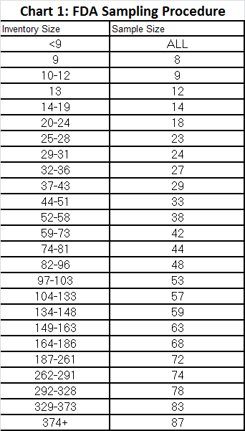

That left the following establishments per category:

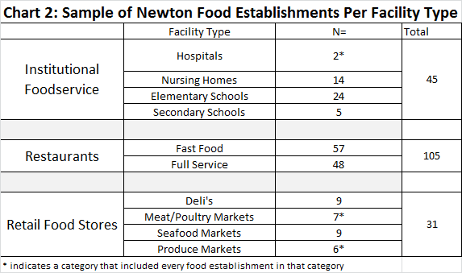

*Random Sampling Procedure*

The procedure used to randomly sample the minimum number of establishments from our separated lists, was to first alphabetize the full lists and assign a number to each food establishment that fell within that list. We then were able to use a random number selector from our inspection database that chose the minimum amount of numbers per category. The remaining food establishments that were not selected were placed on a substitute list. This random sampling procedure allowed us to eliminate selection bias in our sample.

*Inspections & Results Database*

In order to complete all of the inspections in a reasonable period of time, the City hired a consultant, Pamela Ross-Kung. It would have been ideal to use an internal inspector, Robin Williams for every inspection as she is known to all of the Newton restaurants, and she is a “Massachusetts Standardized inspector”. However, due to time constraints and other job duties besides food safety inspections, internal inspector could not be used for all inspections. The inspector that was hired to help with the inspections, Pamela, is very familiar with the Standard 9 Risk Factor Study, and with the Newton restaurants. She has worked with the FDA inspection form before and has also worked with the Environmental Health (EH) Staff. The consultant will help with the majority of inspections and the remainder will be completed by the EH Staff. Initially we had hoped for all inspections to be completed by one person in order to have a consistent standard of measurement, however, due to monetary and time constraints multiple inspectors were used.

*Data Collection*

Newton will use the FDA provided risk factor inspection form in order to stay consistent with the previous FDA reports and consistent with the other risk factor reports that have been done. The risk factor inspection form (Appendix A) includes the five major categories of foodborne illness risk factors (and one additional category “Other”) identified by the FDA. There are subcategories within each major category containing more specific areas to be observed by the inspector. The 42 items on the inspection form follow the 1997 FDA Food Code (see Marking Instructions sheet Appendix B, and Baseline Data Collection Form Appendix C). As of the date of this study, Newton is using the 2009 FDA Food Code. As a result, these inspections were not used as Routine inspections by the inspectors and were solely used for the Baseline audit. We will be using the Microsoft ACCESS database provided on the FDA Retail Standards Resource Disc for recording results and generating the data. Microsoft ACCESS will also allow for a uniform report (consistent with what FDA uses) and ease of reporting given the reporting tool has already been added to the ACCESS database.

The food establishments that were included in the study sample are identified above. The risk factor audit inspections started in June of 2014 and were completed in July of 2015. In an effort to stay consistent in the way reports were done, the five Newton Environmental Health Inspectors completed a small portion of the risk factor audits (59) and the rest (122) were completed by the hired food safety consultant, Pamela Ross-Kung.

The inspectors or consultant completed all inspections unannounced and anything that the inspectors or consultant found that warranted corrective action was given a Corrective Action Plan form which they had to complete (Appendix D) (in a given amount of time) and return to their assigned inspector. The inspectors utilized the following descriptions when assigning a category as IN (In compliance), OUT (Out of compliance), NO (Not Observed), or NA (Not Applicable).

**Newton Risk Factor Study Analysis Results and Summary**

The Newton Risk Factor Trend Analysis Results and Summary is meant to give the City of Newton Health and Human Services Department information about the state of Newton’s food safety. The results are meant to provide baseline data to be compared to the national baseline study1. It also provides Newton with baseline data to be compared to subsequent studies in Newton to be performed every 5 years and areas that the inspection program, and as a result food safety in general to improve upon.

All data acquired from the study can be found in Appendix E.

1. Foodborne Risk Factor Trends for Facility Types (Chart 3)

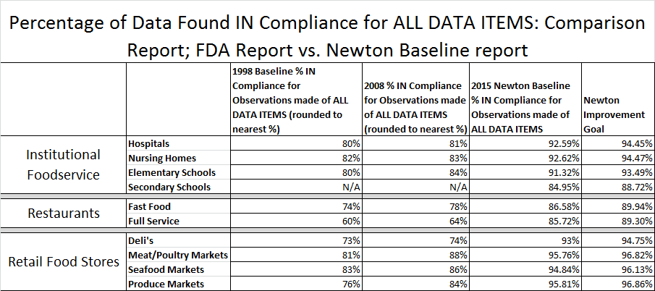

*Data in graph: FDA Trend Analysis Report on the Occurrence of Foodborne Illness Risk Factors in Selected Institutional Foodservice, Restaurant, and Retail Food Store Facility Types (1998-2008), Retail Food Team (see Appendix J in cited report), 2008. <http://www.fda.gov/downloads/Food/FoodSafety/RetailFoodProtection/FoodborneIllnessandRiskFactorReduction/RetailFoodRiskFactorStudies/UCM224152.pdf>

The first data item that came out of Newton’s Baseline Risk Factor Study Report is the % IN Compliance for all data items. This chart shows the FDA 1998 Baseline1, the FDA 2008 follow-up report3 and this baseline Newton Study. The percentages in each column indicate the percentage of items marked “IN” of each facility type (with supplemental items).

Newton’s baseline Risk Factor Study is meant to identify areas that Newton’s food safety program can improve. Since it is the first time the study has been completed, there are no previous numbers from Newton that we can compare this study to. Therefore, we have set improvement goals for each facility type to look at with our next study. The last margin of the chart indicates a 25% improvement goal for IN compliance items for all food establishment types for the next Newton Risk Factor Study.

Obtaining the 25% improvement goal figure:

Example: Hospitals: 7.4% OUT of Compliance for all risk factors

7.4% x 25% (improvement) = 1.85%

7.4%-1.85%= 5.55% (OUT of compliance for the following study)

100%-5.55%= 94.45% (IN compliance for the next study)

Chart 3 illustrates data that shows that in general, Newton’s food establishments are 85% In Compliance with the risk factor violations identified in the inspection report. Newton’s data indicates greater IN Compliance data in every category of food establishment compared to the FDA national data1,3. The most comparable data is in the Restaurants food establishment category which contained the majority of Newton’s data points. The FDA Baseline restaurants showed a 74% and 60% IN Compliance for Fast Food and Full Service restaurants respectively. The 2008 follow-up FDA Risk Factor Study obtained improved numbers of 78% and 64% for Fast Food and Full Service respectively compared to Newton’s baseline of 86.58% for Fast Food and 85.72% for Full Service restaurants. Newton’s data 86.58% for Fast Food and 85.72% for Full Service is greater than both the FDA’s data for the Baseline study and the follow-up study, but there is room for improvement.

*The FDA Baseline study had 895 total inspections compared to Newton’s 181 inspections, therefore, the lower sample size may be the cause of the increased percentages of in Compliance data from Newton compared to FDA.

1. Data Item Trends for Each Foodborne Illness Risk Factor

The three charts below illustrate the data item trends for each foodborne illness risk factor separated by food establishment type (Institutions, Restaurants, and Retail Stores). The foodborne illness risk factors that were identified in Table 2, 3 and 4, below, are food from unsafe sources, inadequate cooking, improper holding, contaminated equipment, poor personal hygiene, and ‘other’. The other category includes storage and use of chemicals that may attribute to foodborne illness risk.

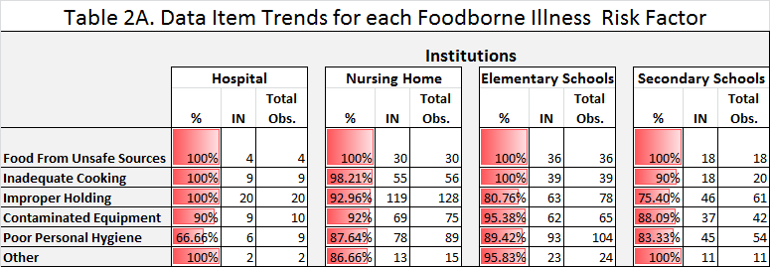

The numbers that are indicated in the Institutions category show that the following categories need improvement: Improper Holding, Contaminated Equipment, and Poor Personal Hygiene. In each institution listed, all percentages are low for the risk factors identified. Given the low amount of observations in the Hospital category, the resulting numbers are difficult to gather appropriate and significant results. Elementary Schools and Secondary Schools showed lower percentages in Improper Holding, which, given the population of individuals served, this is a somewhat concerning data point. Poor Personal Hygiene was the other concerning data point in this table, represented by lower percentages in all food establishments studied.

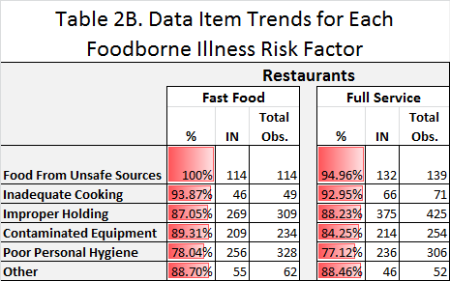

The restaurants category represents the majority of data collected in the study with the greatest amount of observations, therefore, there is greater confidence in this data set as compared to the data collected from Institutions and Retail Food Stores. Poor Personal Hygiene represented the lowest percentage of IN Compliance data points at 78.04% for Fast Food and 77.12% for Full Service. Contaminated equipment was another category that had low percentages (respectively) with 89.31% Fast Food, and 84.25% Full Service. Improper Holding was the final category that was low (respectively) with 87.05% In Compliance Observations for Fast Food, and 88.23% IN Compliance Observations for Full Service.

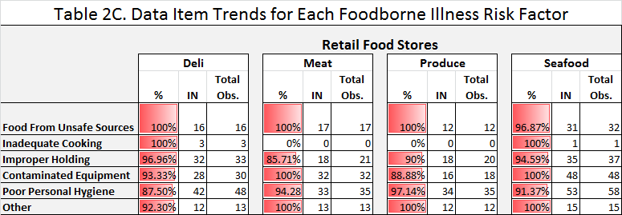

Similar to the above categories, the three categories that represented the lowest percentages of IN Compliance observations for Retail Food Stores are Improper Holding, Contaminated Equipment, and Poor Personal Hygiene. It is clear that these three most popular categories are areas where the Newton inspection program and education need to focus.

For each food establishment represented in the above three tables, a common theme was noted. Poor personal hygiene, improper holding, and contaminated equipment were common risk factors noted in all three food establishment categories. Therefore, Newton environmental health inspectors should pay close attention to these during routine inspections and additional strategies should be utilized to improve all risk factors (see end of report). See “Target Strategies” section of this report for additional information on future recommendations to the Newton environmental health staff.

1. Data Item Trends for Facility Types: Data Items Requiring Priority Attention

The data item trends for each facility type are illustrated below. The data items that require priority attention are those that the environmental staff will work on to address following this report in addition to other pertinent observations that the report shows. There were many recurring trends in common data items that were found out of compliance. The chart below shows the facility type average of IN Compliance Observations. This number is derived by taking the average of the %IN Compliance observations that were recorded for each facility type. We did not include any data item observations that had 0 observations OUT of compliance. We did this to identify the areas that needed improvement (the greater number of OUT of compliance observations, the greater attention needs to be focused on that data item).

**Table 3. Facility Type Average of IN Compliance Observations**

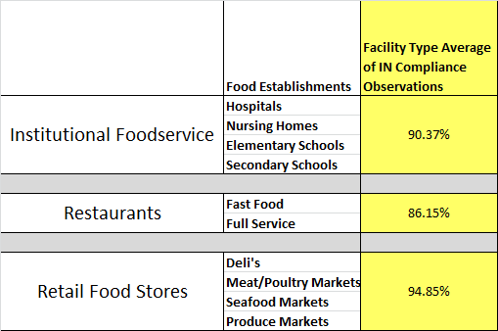

The first chart above, illustrates the facility type average of IN compliance observations. The chart shows that restaurants (fast food and full service establishments) had the lowest average of in compliance observations with an 86.15% average. Institutional foodservice establishments (hospitals, nursing homes, elementary schools and secondary schools) followed with 90.37% average IN compliance observations with retail food stores following with the highest percentage of IN compliance observations with 94.85%. While these numbers, especially the Institutional Foodservice and Retail Food Stores look very high, care must be taken in interpreting this data. There are far fewer observations in these two categories than there are in the restaurants category. That said, all categories were higher than the FDA baseline study completed in 20001.

Graphs 4-13 illustrate the most common data items that were found OUT of compliance. The first column shows the average of % IN Compliance of data items requiring Priority Attention. The second column shows the % of Food Establishments with the corresponding data item requiring priority attention for all types of food establishments. The items that were taken from this chart are all items that overall, require attention. These numbers combined with the percentage of establishments that have the poor compliance illustrates the need for the Newton Food Safety Program to focus on these things.

**Graph 4: Individual Data Items Requiring Priority Attention**

**Common Items Requiring Priority Attention per Facility Type**

**Hospitals**

There were two hospitals that were included in the study. Although there were only two data items for this type of food establishment, the top three “Needs priority attention items” were common throughout all the facility types. Employee Health Policy, Handwash Facilities and Separation were the data items that required priority attention representing 50% and below IN compliance status for each data point.

**Graph 5: Data Items Requiring Priority Attention - Nursing Homes**

There were 14 data items for the Food Establishment type: Nursing Homes. The chart above displays the most common data items requiring priority attention. The data items in this chart that are the most striking are Employee Health Policy, Cold Holding, Separation, Proper Cooling and Proper Cooking Temperature.

**Graph 6: Data Items Requiring Priority Attention – Elementary Schools**

There were 24 Elementary Schools observed in the study. The most egregious data points that required priority attention were: hot holding, handwash facilities, cold holding, food contact surfaces and proper handwashing. Given that elementary schools serve a vulnerable population, all of these data items should be improved upon in the next risk factor study.

**Graph 7: Data Items Requiring Priority Attention – Secondary Schools**

Secondary Schools represented the last major category of Institutional Establishments with 5 Secondary Schools in the study. The graph shows that cold holding, employee health policy, hot holding, separation, food contact surfaces and rapid reheat after hot holding were data points that were below 70% IN compliance. Although only 5 schools are represented here, the data is quite compelling that additional work needs to be done to address better food safety practices in the High Schools especially since the two public high schools are supplying each elementary school with food. In addition to the points that were below 70% IN compliance, proper handwashing, handwash facilities, proper cooking temperatures and proper cooling procedure were also areas that could be improved upon in the next risk factor study.

**Graph 8: Data Items Requiring Priority Attention – Fast Food**

The retail food establishments represented in the study; fast food and full service food establishments contain the largest number of data points at n=57 (Fast Food) and n=48 (Full Service).The data points that represented the lowest percentage of IN Compliance data points were the employee health policy (just over 20% IN compliance), cold holding (just over 60% compliance), proper cooling, hot holding, and rapid reheating hot holding. Other areas of concern were food contact surfaces, handwash facilities, good hygienic practices, and separation.

**Graph 9: Data Items Requiring Priority Attention – Full Service**

The full service establishments had many of the same priority items as the fast food establishments. The employee health policy, cold holding, records retention, food contact surfaces and handwash facilities were all areas requiring priority attention. Given the number of data items in this category, it is important to closely examine the results that were obtained.

**Graph 10: Data Items Requiring Priority Attention – Deli**

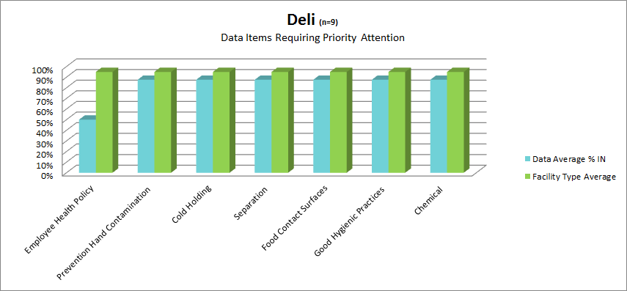

**Graph 11: Data Items Requiring Priority Attention – Meat/Poultry Markets**

**Graph 12: Data Items Requiring Priority Attention - Seafood**

**Graph 13: Data Items Requiring Priority Attention - Produce**

The graphs above represent the retail food markets that were inspected. The same trends remain with these establishments with cold holding, separation, employee health policy, and separation being the most common data items requiring priority attention.

**Table 4: Summary of Items requiring priority attention**

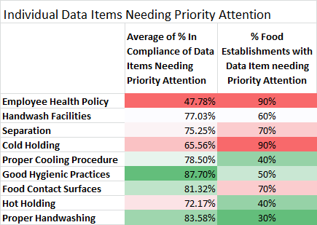

The summary chart above condenses Graphs 4-13 above. The first column in the chart shows the average of %IN compliance data items needing priority attention. Therefore, the lower the percentage, the more significant the data item is. For example, the first row, Employee Health Policy, the first column illustrates that on average 47.78% of food establishments in the study were in compliance with that data item. The second column shows the total percentage of food establishment with the data item in the corresponding row that requires priority attention. For the Employee Health Policy, 90% of Food Establishments had the Employee Health Policy as a data item requiring priority attention. The rows are formatted to show red for a low percentage (first column), or high percentage (second column), this format is shown to more easily see the trouble areas. In this chart, the red “trouble areas” are: Employee Health Policy, Cold Holding, Hot Holding, Separation, and Handwash Facilities.

**Field and Statistical Limitations**

*Inspection personnel*

The majority of the City of Newton’s Baseline Risk Factor Study inspections were completed by hiring a food safety consultant, Pamela Ross Kung. Newton’s environmental health specialists complete housing, tanning, animal, septic, well and other inspections and did not have the capacity to complete all of the risk factor study inspections, therefore hiring a consultant was necessary in order to complete the study. The consultant, although very experienced, is not an FDA standardized inspector. She had several meetings with the environmental staff and was able to become part of the team completing most of the risk factor study inspections. The remaining inspections were completed by the environmental health staff and included Robin Williams, John McNally, Kyle Simpson, Lucy Yen (while she was employed by the City), and Kofi Appawu. It is understood that there may be discrepancies in the way inspections are performed with as many people as there were taking reports. The inspection forms were collected and inputted into the ACCESS database by Aimee Sullivan, Standards Coordinator. Introducing a seventh person to the process can also attribute to a certain amount of error.

*Number Values*

Newton is a City with approximately 420 food establishments. The sampling procedure and the ability of our consultant and inspectors prohibited us from completing any additional inspections than the required amount (to remain a random enough sample). In some cases we only had two establishments representing a category which resulted in low statistical significance of the data that we received for that category.

*Data Comparability*

The data shown in Chart 3 compares Newton’s data with the FDA national baseline data. These two data sets are significantly different in the number of establishments sampled with 895 in the FDA study and 181 in the Newton study. This difference will affect the data obtained and compared. The FDA study was also completed in 2000. The difference in the amount of food safety knowledge that has been obtained since 2000 is quite substantial given that 3 FDA Food Codes have been released since the study, and many changes have been made to update food safety practices.

In addition to comparability to the FDA Baseline and follow-up risk factor study data, the data that is compared in the Newton study between facility types (Restaurants vs. Institutions vs. Retail Food Stores) should be carefully interpreted. The number of establishments that are included in each category is vastly different with Institutions (N=45), Restaurants (N=105), and Retail Food Stores (N=31), therefore a low sample sizes between the three categories results in a low statistical power and therefore decreased comparability between the data sets.

**Targeted Intervention Strategy**

The data from the risk factor study outlines areas that the Newton Environmental Specialists, as regulators of the foodservice industry, need to address. It is the responsibility of the Newton Environmental Health team to show a marked improvement in these areas in order to ensure safe food handling is practices in all food establishments at all times. Reducing the risk factors of foodborne illness is the goal for the next five years between this baseline study and subsequent studies. There are many common themes to the data shown above and the following strategies to address these areas and the risk factors are shown below.

1. *Continued Training*

The food service industry is one that by nature, has a great deal of employee turnover and changing hands of managers/owners etc... These changes lead to changing staff and disrupted food safety protocols. In order to address this ever-changing environment, monthly food safety trainings will be offered in order to hopefully increase the compliance with the food code and requirements set by the food safety regulators. Training food establishment employees aims to help reduce the CDC identified risk factors.

1. *Implementation of a Grading System*

Newton has begun grading restaurants as of October, 2015 in hopes that posting a grade as a result of a food safety inspection will result in increased compliance with the regulations that are required for food establishments in the FDA Food Code and with increased compliance with the Food Code, reducing CDC identified risk factors.

1. *Updating the Food Code*

As of this Risk Factor Study, the City of Newton was following the 2009 FDA Food Code. Regulations were passed to adopt the grading system in October, 2015, the 2013 FDA Food Code was adopted, and with it, the most recent updates to violations, changes, and most current ruling on food safety. The changes and most current ruling on food safety is meant to reduce the CDC identified risk factors. (Appendix F shows the updated regulations from after the study, October, 2015)

1. *Adherence to the 9 Retail Program Standards*

As of the date of the Risk Factor Study, Newton is currently in compliance with 4 out of 9 FDA Retail Program Standards. The Retail Program Standards are a great way to remain current with departmental operations and protocols, remain connected to the restaurant industry and consumers, and ensure that each environmental specialist is trained according to FDA standards. Adherence to the 9 Program Standards ensures that Newton’s food safety program has the most up-to-date food safety program and having a program like this ensures that food establishments are being inspected on a frequent basis, and the inspections that are being done are according to FDA protocol and with that, closer attention paid to the CDC identified risk factors.

**Sustainability Plan**

Newton’s Risk Factor Study must be completed every 5 years, therefore the next study that must be completed should be in 2020. In order to complete another successful study, the following must occur:

* **Utilizing current inspectors:** The 2015 Newton Baseline Risk Factor Study was completed by hiring a consultant to complete the majority of the inspections. Although this was not ideal considering the cost, it was a great way to utilize grant funds and free up time for the environmental health staff. In the future, the grant that funded this project may no longer be available, therefore, Newton’s environmental specialists will be utilized to complete the Risk Factor inspections. Although it is not recommended to have more than one person completing inspections as it increases the subjective bias that an inspector could have for completing inspection forms, by 2020, all environmental inspectors will be FDA standardized. The FDA standardization of all environmental inspectors will help with the subjective bias because the way inspections are completed for standardized inspectors is the same.
* **Conducting inspections:** When the Risk Factor Study needs to be completed in 2020, the inspectors will conduct Risk Factor inspections concurrent with their routine inspections. This will be the only way that the inspectors will have enough time to complete the additional risk factor inspections and also complete their other job duties.
* **Data Input:** The inspection forms that are filled out for the Risk Factor Study will be inputted into the ACCESS database as before. The inspectors will input into ACCESS after completing an inspection. Or an intern can be hired for data entry and report writing.
* **Report write up:** The report write up will require designated hours from the environmental staff or intern. The format of the report should follow the format of the 2004 FDA Report on the Occurrence of Foodborne Illness Risk Factors in Selection Institutional Foodservice, Restaurant, and Retail Food Store Facility Types (2004). The reason the 2004 report was chosen as opposed to the 2008 report, is that the 2004 Report follows up on the 2000 report (The FDA Baseline Study) and as ours would be following up on our Baseline study, the data descriptions would be the most similar to ours.
* **Standard 9 Audit:**  When the report is complete, another audit should be scheduled and Standard 9 should be audited for completeness once more.

In the years following the 2020 report, similar protocol should take place in order for Newton to remain in accordance with Standard 9.

**Citations**

1. **“Report of the FDA Retail Food Program Database of Foodborne Illness Risk Factors”. Prepared by the FDA Retail Food Program Steering Committee. 8/10/2000** [**http://www.fda.gov/downloads/Food/GuidanceRegulation/UCM123546.pdf**](http://www.fda.gov/downloads/Food/GuidanceRegulation/UCM123546.pdf)
2. **“Developing a Baseline on the Occurrence of Foodborne Illness Risk Factors: Data Collection Instruction Manual” 4/28/03. FDA Resource Disc available upon request of FDA Regional Representatives.**
3. **“FDA Trend Analysis Report on the Occurrence of Foodborne Illness Risk Factors in Selected Institutional Foodservice, Restaurant, and Retail Food Store Facility Types (1998-2008). Prepared by the FDA National Retail Food Team. 2010.**