T-VILLE TRAILS 2022
Special Events are tentative. Camp runs Monday through Friday

SUN | MON | TUES | WED | THURS | FRI | SAT
July 3  Anything Goes  week | 4  NO CAMP  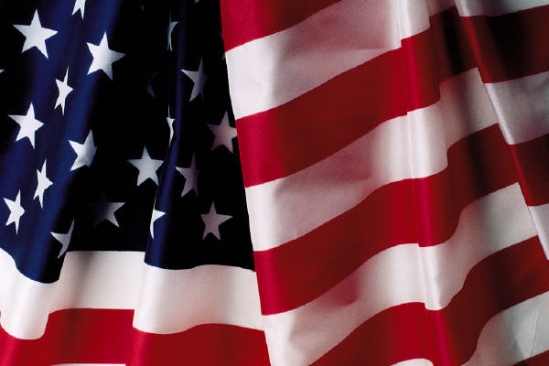 | 5  Camp  Starts | 6 Funny Hat/Crazy Hair Day  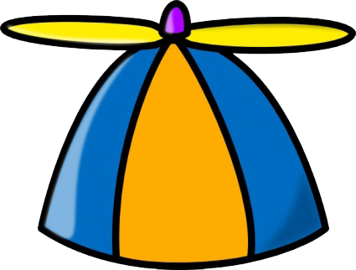 | 7  Halloween  in the  Summer | 8  Magic Show   | 9  
10  Mad Science  Week | 11  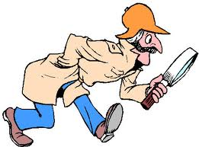 | 12  MoS  Planetarium   | 13  Inventors  LAB   | 14  MAD SCIENCE  WORKSHOP   | 15  MoS Rockets  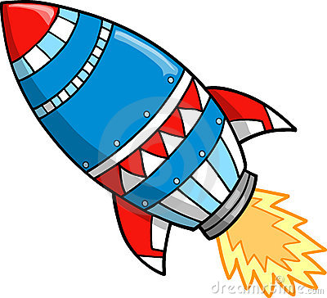 | 16  
17  Sports &  SPIRIT  WEEK | 18 | 19  Knucklebones  Sports Party  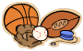 | 20  Team Spirit  Day & Tie Dye  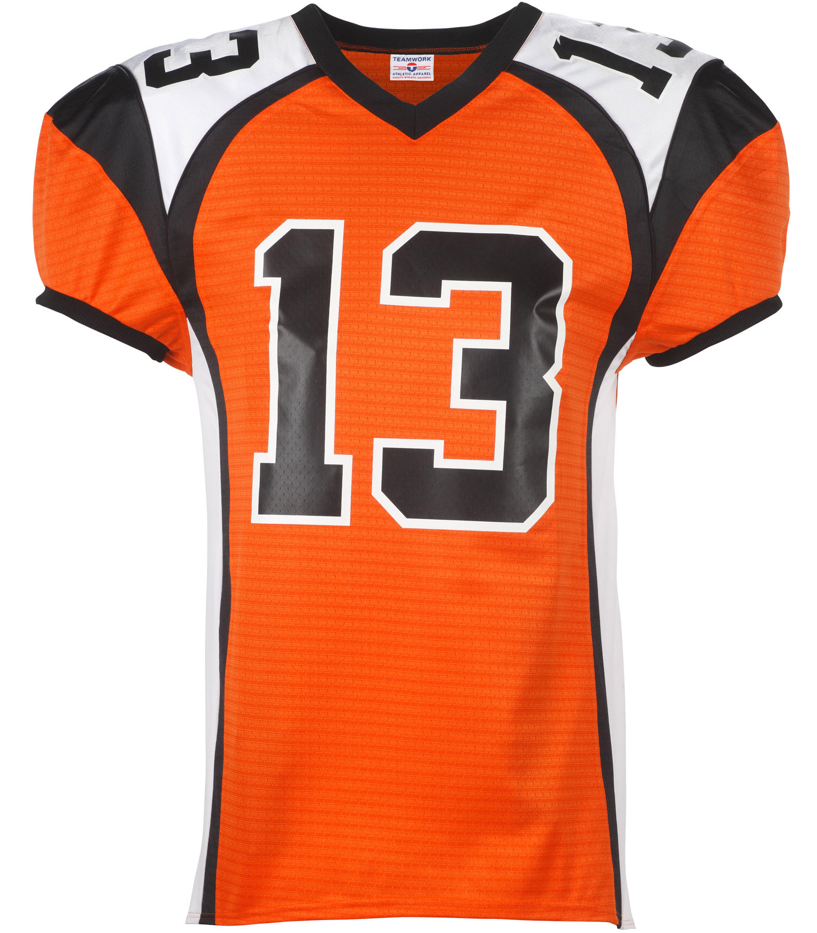 | 21  Frisbee  Dog Show  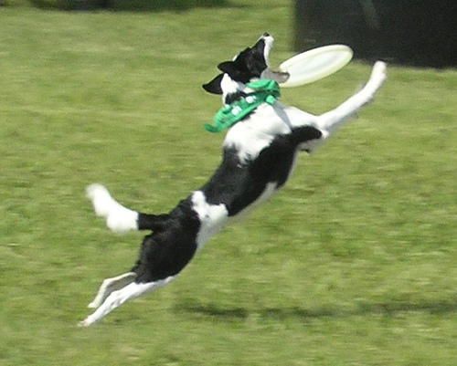 | 22  Color Day   | 23  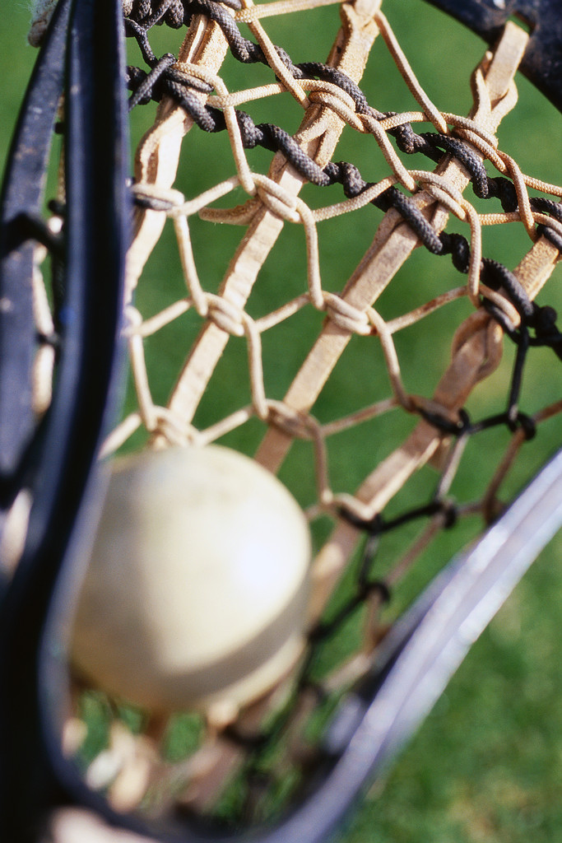
24  aNIMAL plANET  wEEK | 25 | 26  Wingmasters  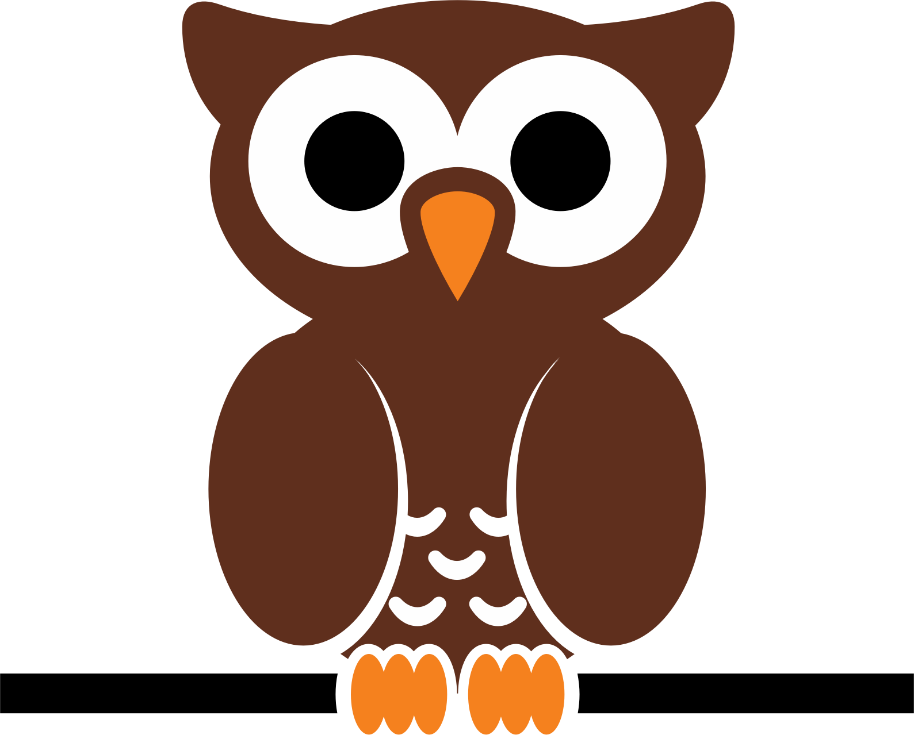 | 27  Animal Adventures  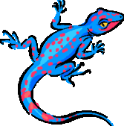 | 28  Animal Craze  Petting Zoo  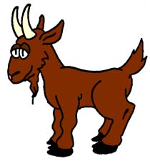 | 29  NEAQ Touch Tank  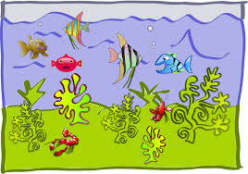 | 30  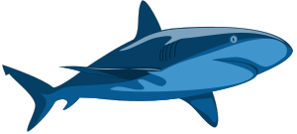
31  Carnival  Week | Aug 1  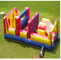 | 2  Inflatable Slip ‘n Slide  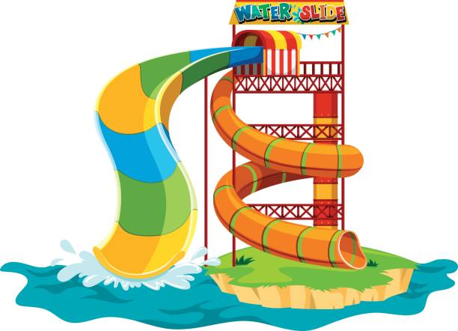 | 3  Stuff your  Own  Animal  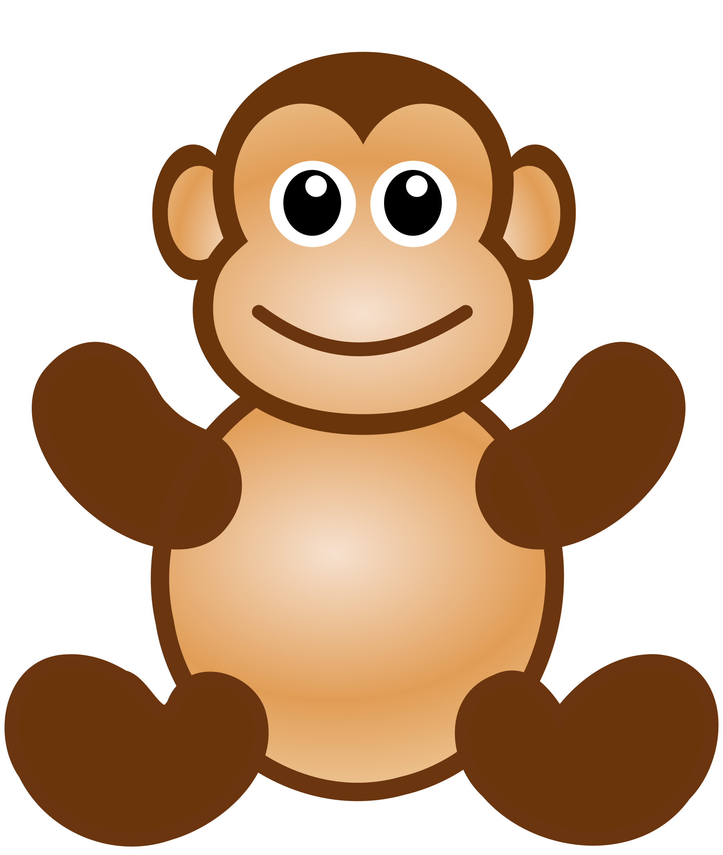 | 4  DUNK TANK  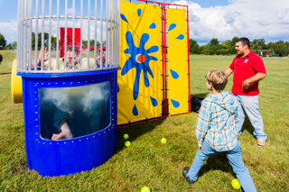 | 5  Camp  Carnival/  Inflatables   | 6
7  Wild, Wild  West  Week | 8 | 9  Old Ghost Town Laser Tag  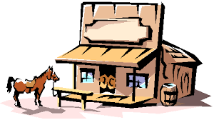 | 10  Wild West  Dance Party | 11  Big Joe  the Storyteller  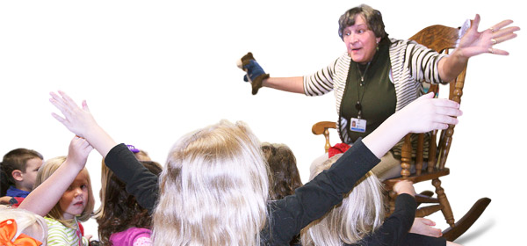 | 12  Gold Rush   | 13
14  T-Ville’s Got  TALENT WEEK | 15   | 1  Big Daddy’s  Racing | 17  Pajama Day | 18  Movie Day  Fun Flicks | 19  Camp Show |   20

