July 30, 2026

Re: Friends of Wellington Park Proposal for new Playground Equipment at Wellington Park Staff Notes

Dear Parks and Recreation Commission,

The Parks, Recreation and Culture Department (PRC) is pleased to present the playground equipment improvement proposal by the Friends of Wellington Park (FWP). Please see figures below that highlight the proposed improvement plans.

E

Listed below are staff notes resulting from the collaboration between PRC and FWP.

Staff Notes on Wellington Park Playground Equipment Proposal:
- The proposed playground equipment will be manufactured by Kompan and constructed of appropriate playground materials that will resist weather elements and degradation. The large equipment will be contained in a new playground area with the approximate perimeter dimensions of 37 feet by 37 feet with rigid plastic edging. This equipment will serve the neighborhood youth population ages 5 to 12 years old. Playground mulch and ADA rubber surface matting will be installed for accessibility within the area.
- The equipment will be placed adjacent to existing sidewalks to promote ADA accessibility.
- PRC will have the equipment installed by a qualified contractor through the public bid process. The equipment will be placed not to conflict with any underground utility lines or existing trees.
- The Parks and Recreation Superintendent and Playground Manager did not have any issues with the playground equipment installation.
● A formal gift letter shall be provided from FWP, addressed to Commissioner
Banks, stating the desire to gift the new playground equipment to the City of Newton.
● FWP shall fundraise 100% of the installation and material costs for the playground
equipment, and its deferred maintenance costs.
● The volunteer group stated the material and delivery costs are approximately $62,300.00.

Existing Photos

Taken From Kilburn Road Gate Entrance
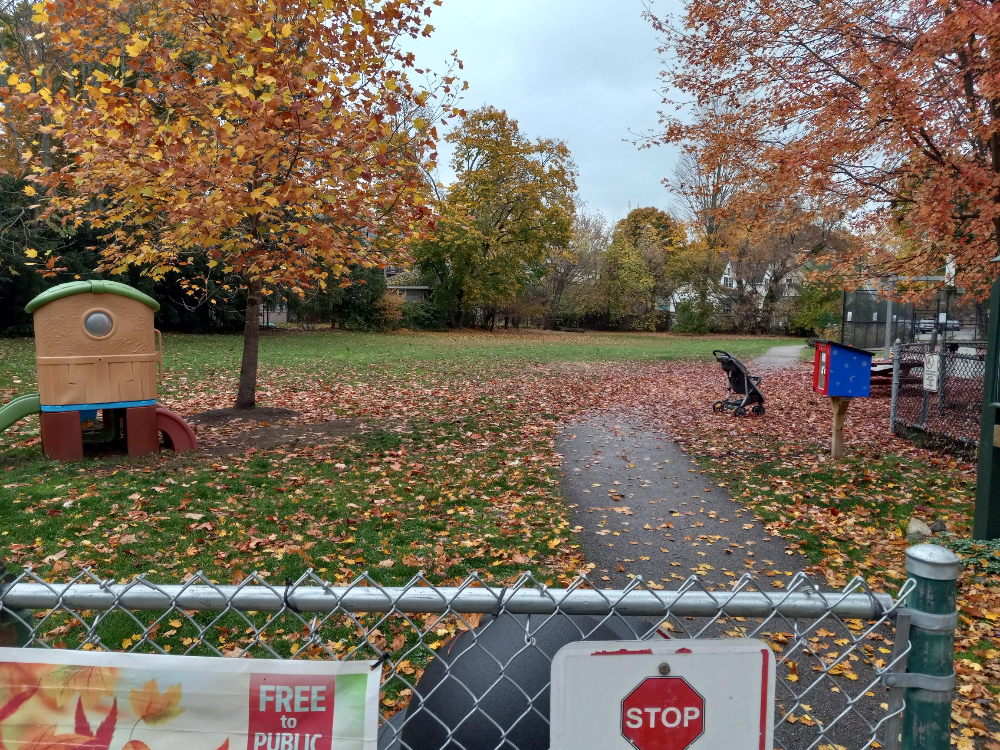

Taken from inside park looking towards Kilburn Road
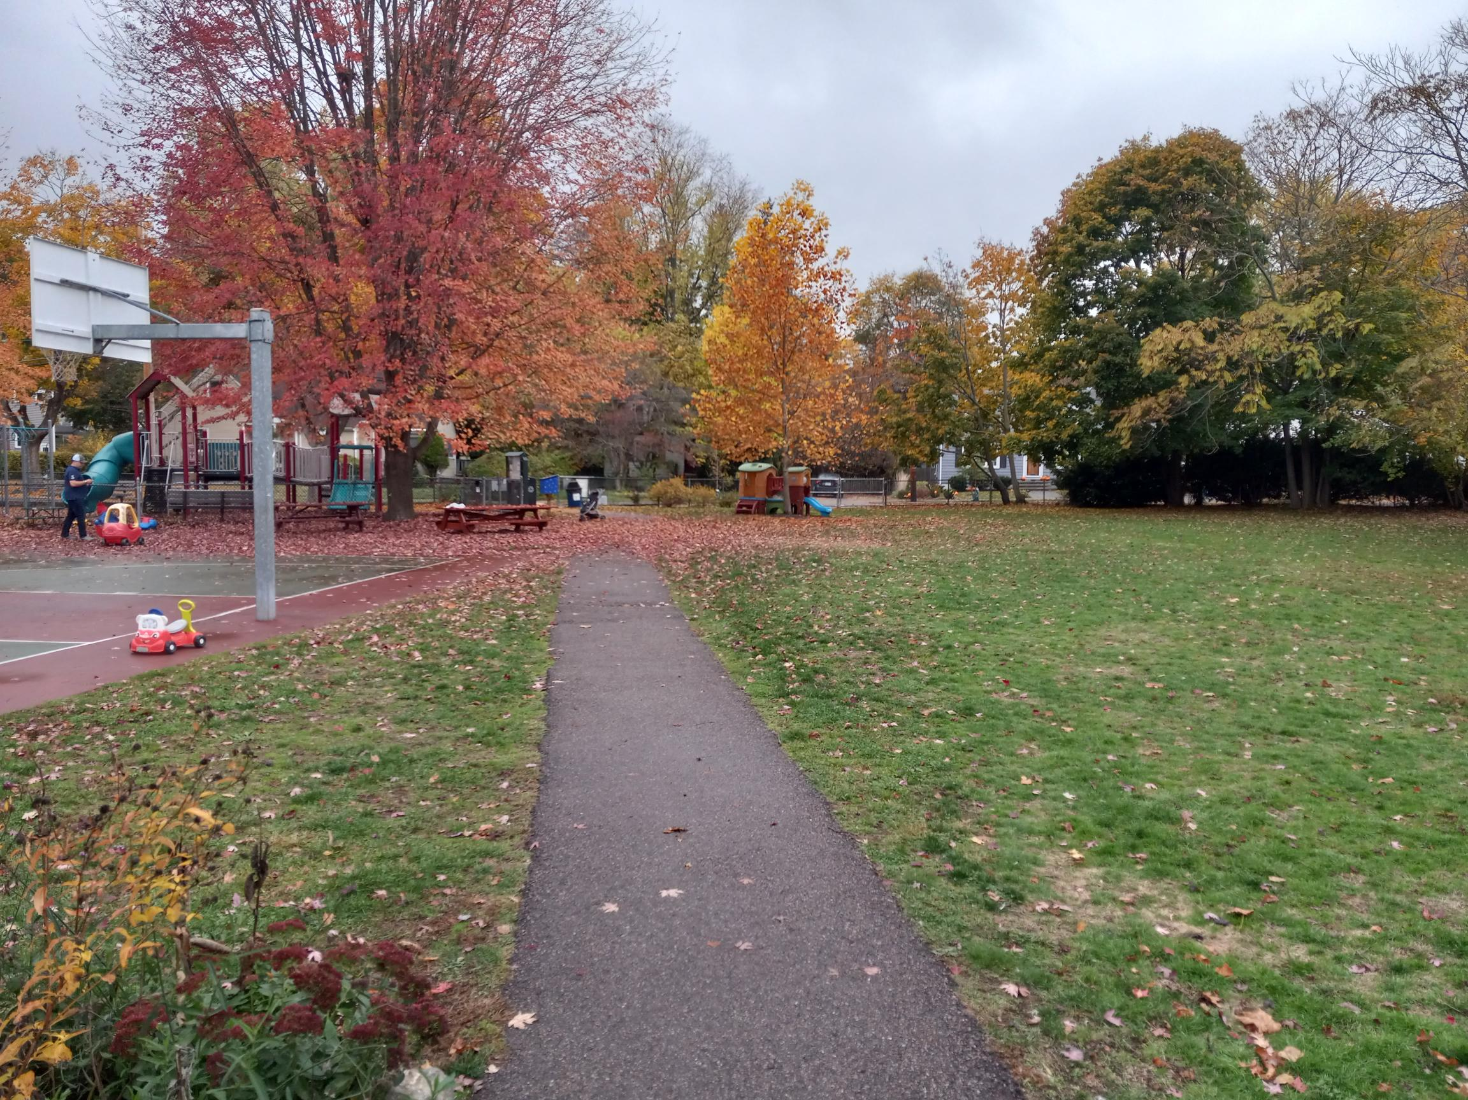

Existing Wellington Park Conditions with Proposed Equipment Location

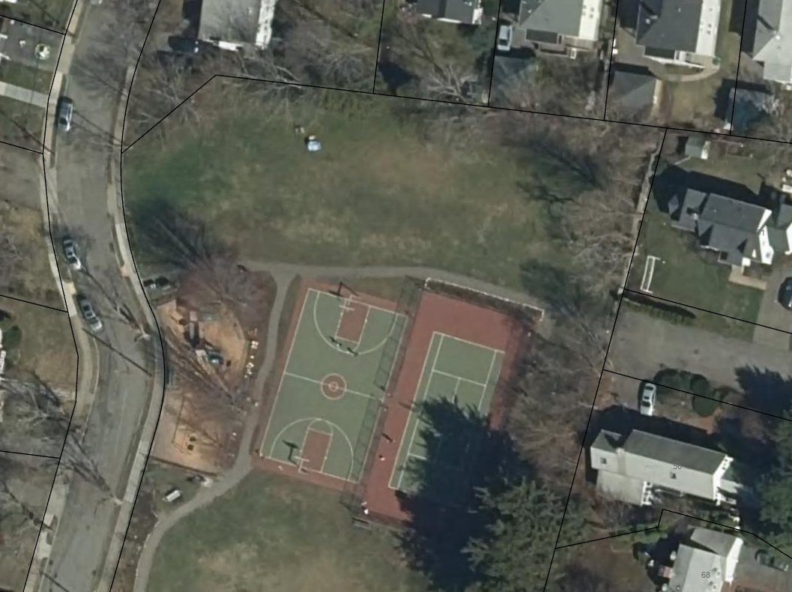

Sincerely,
Gregory Mellett
Proposed 1370 SF playground equipment area
Gregory Mellett
____________________________
Assistant Director of Parks + Open Space
Parks, Recreation & Culture
City of Newton

