**New Website Cheat Sheet Updated Tuesday, December 13, 2022**

**Login**To access, modify and update as an admin, just add **/admin** to end of the URL. This will get you to the login screen. [https://www.newtonma.gov/admin](https://gcc02.safelinks.protection.outlook.com/?url=https%3A%2F%2Fprotect-us.mimecast.com%2Fs%2FGK5BCVONRKU00k2ptJSYn7%3Fdomain%3Dgcc02.safelinks.protection.outlook.com&data=04%7C01%7Cjmulvey%40newtonma.gov%7C6426763ef2b24e278e0308d88cd5e1b8%7C2a3929e0ccb54fb381402e2562c90e96%7C0%7C1%7C637414198672446361%7CUnknown%7CTWFpbGZsb3d8eyJWIjoiMC4wLjAwMDAiLCJQIjoiV2luMzIiLCJBTiI6Ik1haWwiLCJXVCI6Mn0%3D%7C2000&sdata=UW3Wbh4N9NcudcTZ1r4%2BmqDSvlDZahZSGgp%2BWIn9y50%3D&reserved=0)

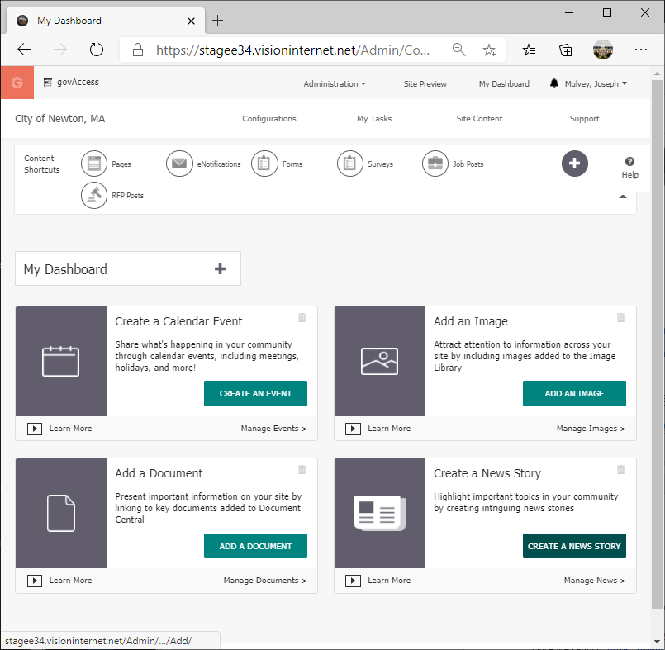 **Dashboard 🡪**

**Civica Filebank equivalent is now Document Central**After login, you will arrive at the dashboard – a very customizable screen.

Choose **Add A Document** or   
hover over *Site Content* and click on Document Central. You can add multiple documents at once by browsing to a folder or dragging and dropping into the appropriate dialog box.

Once selected, choose a content group so documents may be **saved** AND **published**. You can select all and publish all at once.

**Add a Link to a document on your webpage  
**

* Document(s) have been uploaded to Document Central
* Browse to the page hosting the link to the document, click Edit
* Type the display name (not the file name) by which you wish to identify the link
* Highlight this text, click on the Documents icon
* Browse to the file
* Click OK

**If you are updating a revision of an existing document (keep the URL intact):**

* Browse in document central the file to be replaced
* On the right side click on the shaded circle and select Update
* Browse to the source of your replacement file

**Add a link to another city webpage**



Use the Internal Links button to navigate to the desired link page on the newtonma.gov website

**Add an External link (another site)**



Use the hyperlink manager to link to non-City sites, email addresses, etc.

**Image Central** is now the repository for all pictures and graphics.

**Content Group**When creating events in **Calendars**, a bid in the **RFP module**, a news item in **News Story** and anywhere else you see the prompt, you must select a Content Group from the drop down. We recommend using your own department unless you are creating entries for another division, group, or department.

**Edit an Existing Page**

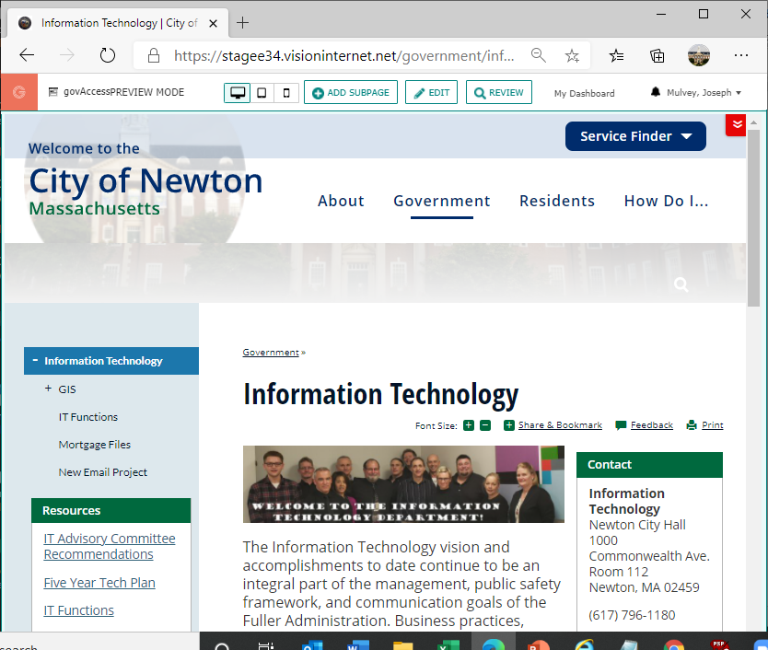



The above is the short version of the page editing interface.

If you need the full editing solution click on the wrench in the content area.



**Calendar**

Section 1 – Summary

* First - Upload any attachments to Document Central and any images into Image Central.
* Choose Add an Event
* Always select a **Content Group**.
* The Title will be used by default on any social media posts if applicable, if you do not customize the posts.
* The Date and Time of your event represent the beginning and end of it.
* The Subtitle is optional but gives a place to provide an extended title.
* The Intro is optional and will be seen on the Events List widget view.
* Thumbnail is optional and will also display on the Events List widget view.
* Location is optional. If your Facility Directory component has facilities in it, you will see them in the drop-down menu here. Virtual is an option.
* Tags are labels to include this Event with other related content. Tags don't need to be configured prior to this; you can add them to the field ad-hoc.
* Categories available are dependent upon the selected Content Group. **We recommend choosing exactly ONE of these three: City Meetings, Events, Programs**. These will be color coded according to the home page buttons.
* Departments are tags like Categories

Section 2 – Details

* The Details section provides the full Editor Tool as seen throughout the components. With the Editor Tool, you can add links, images, document links, tables, and formatting.
* You can also toggle the view from Design editor to HTML editor, in which you can paste an embed code or an iframe.
* Below the Editor Tool, there is a field to attach any supporting documents from the Document Central to your Event.
* Under channels select the **Display On Home** button to have your entry appear on the home page

Recurring Events and other modifications

* Clicking on the circle at the end of a calendar entry in the calendar list brings up some options including Edit, Copy and Make Recurring.

